The Ising Model

**Contents**

1. Introduction
2. Monte Carlo Simulation
3. Results
   1. Ferromagnetic
   2. Antiferromagnetic
   3. External Field
4. Conclusion

**Abstract**

The Ising model allows the behavior of the spins in a ferromagnetic and antiferromagnetic material to be illustrated by a two dimensional lattice of spins up and down to convey the system. For a ferromagnetic model, the theory predicts that the spins will align at low temperatures and randomly for high temperatures. For an antiferromagnetic model, the theory predicts that the neighbouring spins will be opposite at low temperatures, and again randomly align at higher temperatures. This means there is a phase transition defined by a critical temperature. These results will be checked with a Monte Carlo method. To start only the internal interactions were considered and the results were considered. Then an external magnetic field was applied. For T < TC the aligning of the spins is only possible if the field is large enough. For T > TC the spins tend to align with it, although at high temperatures it’s affect is not significant due to thermal agitation.

**1 Introduction**

The Ising model is a mathematical model of ferromagnetism in statistical mechanics. Introduced in 1925 by Ernst Ising and Wilhelm Lenz. (Huang, 1963)The Ising model has become one of the most researched models in statistical physics. It is defined by the Hamiltonian:

|  |  |  |
| --- | --- | --- |
|  |  | Eq. |

With <i,j> representing the sum over the nearest-neighbours, Si the spin of a particular site which can be of value ±1 (⬆⬇), H is the applied magnetic field and J the interaction strength. We know that:

* J > 0, the interaction is called ferromagnetic.
* J < 0, the interaction is called antiferromagnetic.
* J = 0, there is no interaction between the spins.

In a ferromagnetic model, the spins tend to be aligned. This is a result of the system in which the neighbouring spins have the same sign is of a higher probability (Figure 1 ). For the antiferromagnetic model, the spins tend to have the opposite sign of their neighbours (Figure 2).

⬆ ⬆ ⬆

⬆ ⬆ ⬆

⬆ ⬆ ⬆

⬆ ⬇ ⬆

⬇ ⬆ ⬇

⬆ ⬇ ⬆

Figure

Figure

The nearest-neighbours in this case are located directly above and below the particular site and directly to either side.

From the Hamiltonian, it is possible to define the partition function for the statistical system.

|  |  |  |
| --- | --- | --- |
|  | , | Eq. |

Where β is the inverse temperature of the system. The magnetization of the system can be measured by taking the average value of the spin.

|  |  |  |
| --- | --- | --- |
|  |  | Eq. |

Where N2 is the number of lattice sites. This factor will not matter in the end, as all of the quantities that will be looked at will be divided by the same factor. This is so that a better comparison can be achieved between different lattice sizes. The magnetic susceptibility of a system can be derived from the magnetization.

|  |  |  |
| --- | --- | --- |
|  |  | Eq. |

The heat capacity of the system can also be calculated.

|  |  |  |
| --- | --- | --- |
|  |  | Eq. |

In 1944 Lars Onsager solved the 2D Ising model for a square lattice with H = 0 (Onsager, 1944). He obtained an expression for the spontaneous magnetization of the system as a function of temperature.

|  |  |  |
| --- | --- | --- |
|  |  | Eq. |

Where

|  |  |  |
| --- | --- | --- |
|  |  | Eq. |

Tc is the critical temperature of the system, also known as the Curie temperature, and has units of J/kB. It is where the phase transition of the system takes place for the ferromagnetic with H = 0. In 1951, Yang (Yang, 1952) gave the first published proof of this formula in direct response to Onsager’s work.

**2 Monte Carlo Simulation**

To find a solution for the Ising model, a N x N size lattice was chosen. To calculate for all possible states in the chosen system is almost impossible. So a Monte Carlo method was used. For this model a specific Monte Carlo method was used also known as the Metropolis Algorithm (Metropolis, Rosenbluth, Rosenbluth, Teller, & Teller, 1953). The configuration of the system is selected randomly. This means that the initial set of the spins starts in a paramagnetic state. The evolution of the system using the Metropolis Algorithm at a specific temperature means that not every configuration needs to be tested, as there are 2N spin configurations. The probability, p, that a site’s spin is flipped is given by the Boltzmann distribution meaning that low energy states are preferred.

|  |  |  |
| --- | --- | --- |
|  |  |  |
|  |  | Eq. |

This means that as the system evolves it can be simulated by selecting a random site from the lattice and calculating the probability for a flip and execute the flip if necessary. When E ≥ 0 the condition for the spin to flip is when a random number from a uniform distribution between 0 and 1 is less then . When E is less than zero the spin is always flipped.

**3 Results**

For the simulation of the Ising model, a 20x20 lattice was used, due to the system taking approximately 10000 evolution steps to reach a confident final state. Periodic boundaries are used so that every site has 4 nearest neighbours in an attempt to get close to an infinite lattice. To use periodic boundary conditions, it is imagined that the arrangements of spins in the lattice are duplicated above, below, to the left and to the right of our original lattice (Figure 3).

⬆ ⬇ ⬆ ⬆ ⬇ ⬆ ⬆ ⬇ ⬆

⬇ ⬇ ⬇ ⬇ ⬇ ⬇ ⬇ ⬇ ⬇

⬇ ⬇ ⬆ ⬇ ⬇ ⬆ ⬇ ⬇ ⬆

⬆ ⬇ ⬆ ⬆ ⬇ ⬆ ⬆ ⬇ ⬆

⬇ ⬇ ⬇ ⬇ ⬇ ⬇ ⬇ ⬇ ⬇

⬇ ⬇ ⬆ ⬇ ⬇ ⬆ ⬇ ⬇ ⬆

⬆ ⬇ ⬆ ⬆ ⬇ ⬆ ⬆ ⬇ ⬆

⬇ ⬇ ⬇ ⬇ ⬇ ⬇ ⬇ ⬇ ⬇

⬇ ⬇ ⬆ ⬇ ⬇ ⬆ ⬇ ⬇ ⬆

Figure

Original

Lattice

With a larger lattice, a larger amount of evolution steps are required for a confident final state to be achieved. Figure 4 below demonstrates how a larger lattice requires more evolution steps.

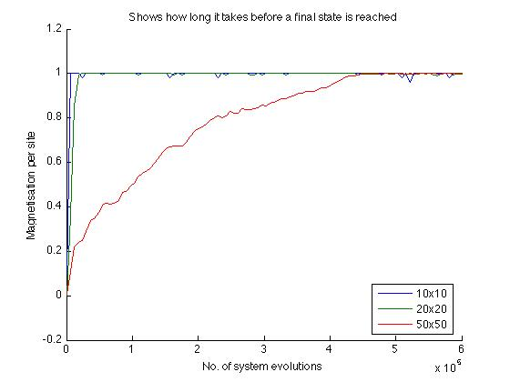

Figure

For all the values taken, the system was allowed to reach a confident final state after enough evolution steps. The values were then averaged over a further 50000 steps, as the system can continue to fluctuate ever so slightly and this was done to accommodate for that. The temperature of the system was selected randomly between 0 and 5.

**3.1 Ferromagnetic Model**

The ferromagnetic model of the Ising model is when the interaction strength between the lattice sites, J, is greater then zero. For the following graphs the interaction strength was set to J=1.

Figure - J = 1

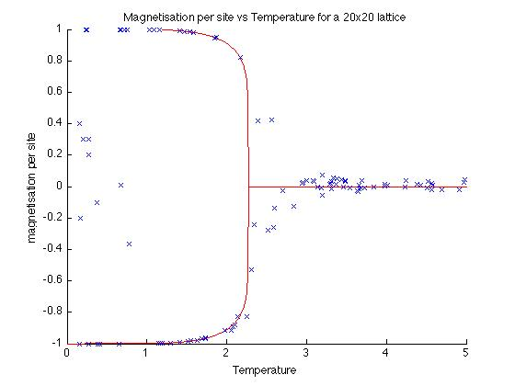

Figure 5shows the magnetization per site, M, plotted against the temperature of the system. The energy per site is shown in Figure 6.

A phase transition can be seen clearly between the temperatures of 2 and 2.5. This is as expected, due to the value of the critical temperature, Tc, which we found from Eq. 7 being Tc ≈ 2.269. Lars Onsager’s exact solution for the magnetization, Eq. 6, has been plotted on Figure 5 as well. This shows that the values agree very strongly with the analytical solution. It is shown for T < Tc that the magnetization falls into the two favoured ground states, where the spins are all aligned. This is either all the spins are up (M=1) or all of them are down (M=-1). This is known as the ferromagnetic phase.

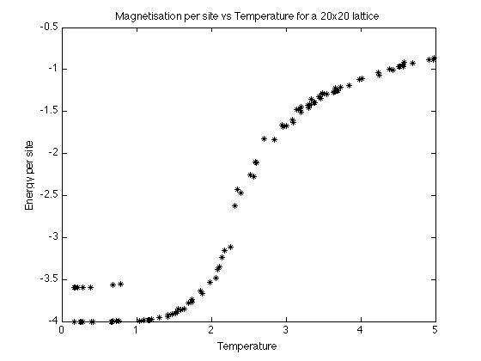

Figure - J = 1

For the low temperatures there is a class of metastable states, this is where approximately half of the spins up and half down. Spins that are aligned form large clusters together, which could explain the higher level in the energy at the lower temperatures, due to the boundaries between the spin up cluster and the spin down cluster increasing the energy slightly from the ground state. With more evolution steps the metastable states would move into one of the two ground states. When T > Tc the spins tend to be randomly aligned this causes the average of the magnetization to average at zero (M=0), known as the paramagnetic phase.

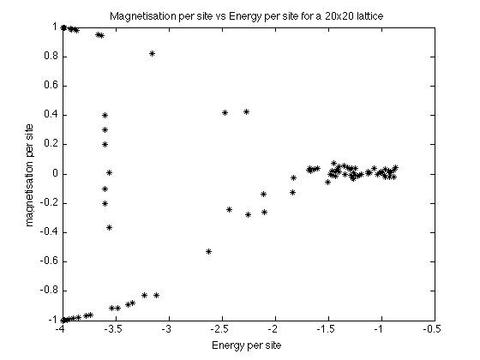

Figure - J = 1

In Figure 7 the magnetization per site has been plotted against the energy per site. It shows us approximately the four possible states that system can be in. The slightly higher density regions on the graph allow us to see the two low temperature ground states (M=±1, E=-4), the system staying disordered at higher temperatures (M=0, E=-1) and where the low metastable states lie (M=0, E=-3.5).

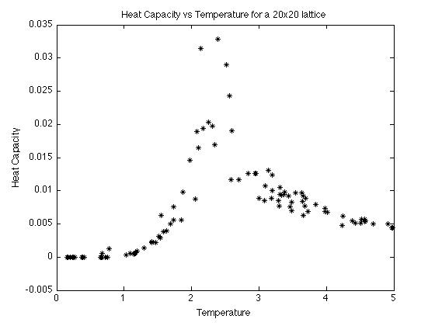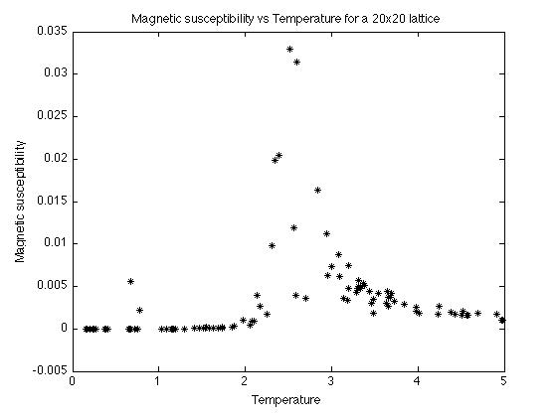

Figure 8 - J =1

Figure - J = 1

Figure 9 - J = 1

Figure 8 shows the heat capacity of the system at each temperature, which shows how much the energy changes with the temperature and it can be seen to peak at T≈ 2.34. This shows us where the phase transition is, as we would expect the heat capacity to diverge at the transition. Figure 9 shows the magnetic susceptibility of the system, which shows us how much the magnetism changes by increasing the temperature and this peaks at T ≈ 2.42. This shows us that before and after the phase transition that the change in magnetization is approximately zero, but at the critical temperature it tends to infinity.

To show what happens to the final state for different configurations, images have been produced to show what the initial state is and depending on the set up of the system, what the final state looks like.

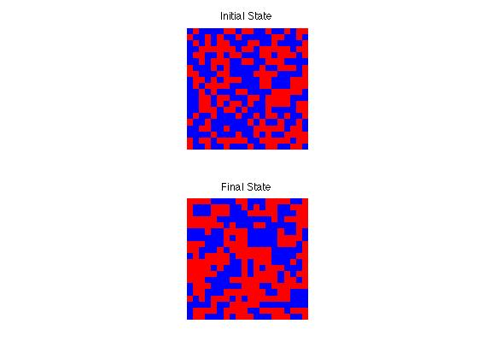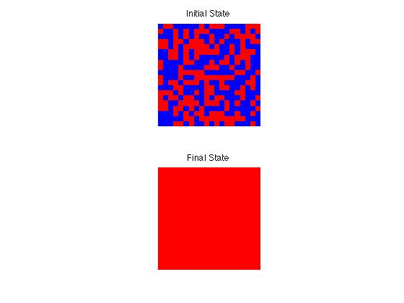

Figure 10 - J = 1 T = 1 H = 0

Figure 11 - J = 1 T = 4 H = 0

Figure 10 shows the temperature set to lower then the critical temperature and it shows how in the final state for how all the spins are aligned. Figure 11 has a temperature greater then the critical temperature and as we saw from figure 5 this causes the magnetization to average to zero and remain disordered. This is a result of the probability for spontaneous flip processes in the system being great.

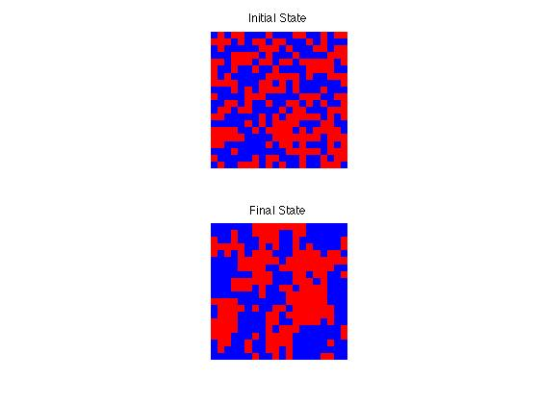

Figure 12 – J = 0.3 T = 1 H = 0

Figure 12 shows how if the interaction strength is reduced, the model for a low temperature acts in a similar manner to that of a system with a high temperature and strong interaction strength.

**3.2 Antiferromagnetic Model**

The antiferromagnetic model of the Ising model is when the interaction strength between the lattice sites, J, is less then zero. For the following graphs the interaction strength was set to J=-1. Unlike the ferromagnetic model, no analytical solution exists for the antiferromagnetic model.

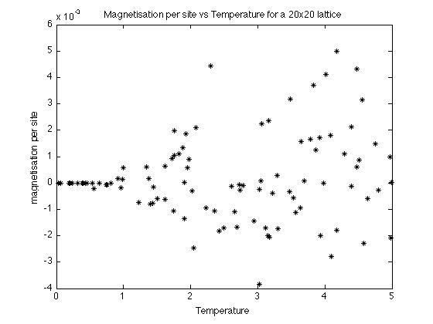

Figure 13 - J = -1

Figure 13 shows the magnetization per site against the temperature of the system. It can be seen that at the extremely low temperatures, where the temperature approaches zero the magnetization is equal to zero exactly (M=0). This is due to all of the neighbouring sites having the opposite value of spin for the entire system (Figure 2). As with the ferromagnetic system, it can be seen that with the system at higher temperatures (T > Tc) the spins are randomly aligned and so are approximately equal to zero, but unlike below the critical temperature it is not always exactly zero.

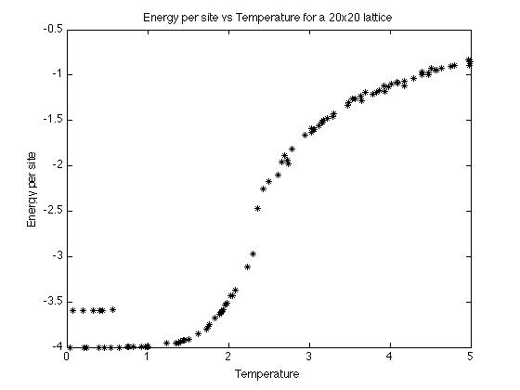

Figure 14 - J = -1

The energy per site is shown against the temperature in figure 14. This is the same as the ferromagnetic model. This implies that there is a phase transition again between what would be the antiferromagnetic phase to the paramagnetic phase. The reason for the two separate energy levels the temperature approaches zero is due to there being more than one possible ground state for the system to lie in due to the nature of the spins all being opposites. This illustrates frustration in the system, which is the inability of a system to find a single ground state to line in.

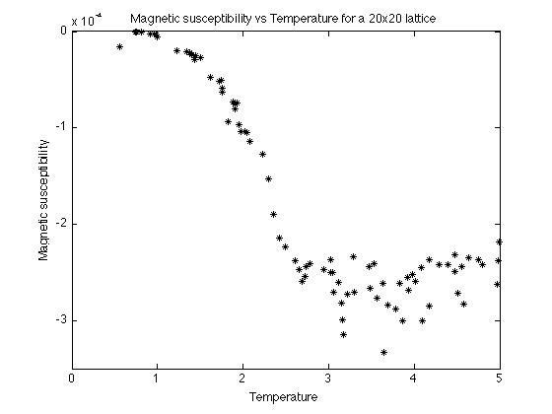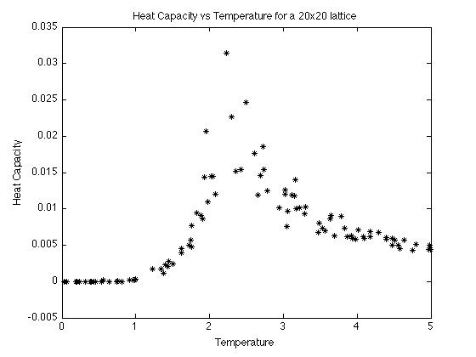

Figure 15 – J = -1

Figure 16 – J = -1

Figure 15 shows the heat capacity against the temperature, which shows how much the energy of the system changes with the temperature. This again peaks at T ≈ 2.31, displaying that there is a phase transition at this temperature similar to that of the ferromagnetic model, but for an antiferromagnetic model this is referred to as the Neel temperature of the magnetic ordering temperature, TN. Figure 16 shows how the magnetism changes with an increase in temperature. Again it jumps at a temperature of T≈ 2.39, but this time it goes negative. This means that it is diamagnetic. When an external magnetic field is applied to a diamagnetic object it is caused to create a magnetic field in the opposing direction, therefore causing a repulsive effect.

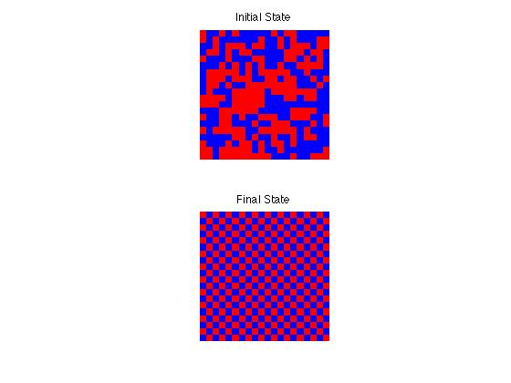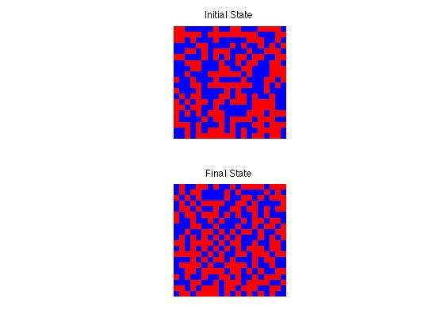

Figure 17 - J = -1 T = 4 H = 0

Figure 18 - J = -1 T = 1 H = 0

Figure 17 shows how the antiferromagnetic system develops from its initial state to final state at a temperature of 4, which is greater then the value of TN. As you can see the system is paramagnetic and the spins have remained in a completely random configuration as was expected. Figure 18 illustrates how at T < TN, the system in its final state is antiferromagnetic where all neighbouring sites have the opposite spin.

**3.3 External Magnetic Field**

An external magnetic field was initially applied to a ferromagnetic model with interaction strength, J = 1.

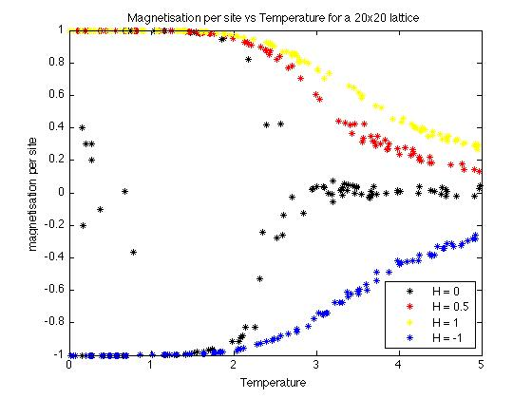

Figure 19 – J = 1

In figure 19 it is possible to see how the strength of an external magnetic field affects the magnetization per site for a given temperature of the system. It shows that an applied external field at low temperatures causes the spins to align in the direction of the applied field. At high temperatures the external field has little effect on the magnetization. It also shows how in general the magnetization is larger when an external magnetic field is applied.

Figure 20 – J = 1

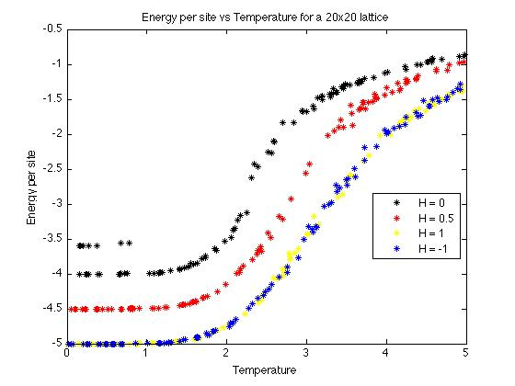

Figure 20 shows the energy per site against temperature for the different external magnetic fields applied. The application of the external field causes the shift of the energy to be less abrupt than without it. The field also causes the energy at lower temperatures to be less. This is a result of less energy being required to cause the spins to all be aligned at this temperature. It also shows how the direction of the field has no effect on the energy, just the magnitude. This is shown more clearly in figure 23.

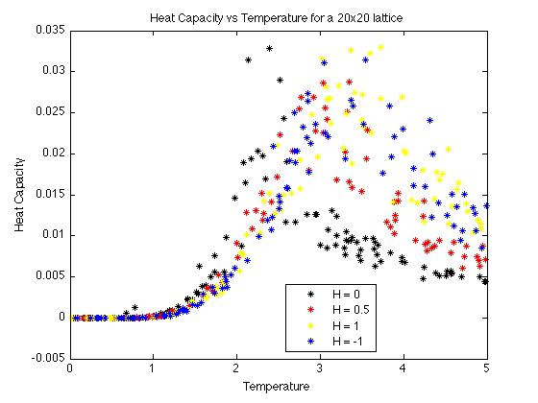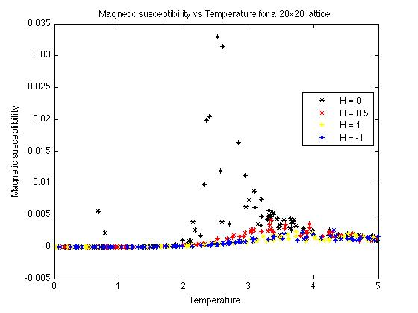

Figure 21 – J = 1

Figure 22 - J = 1

Figure 21 shows how the heat capacity varies for each of the external magnetic fields. The graph shows that as the external field is increased, the peak moves to the right. This means that the phase transition, as can be seen in the energy plot (Figure 20), happens at a larger temperature when there is a larger external field. Figure 22 shows how the magnetic susceptibility varies for the different external fields. It shows that as the field is increased the peak drops off quite significantly, but it also reiterates how the phase transition happens at a larger temperature for increasing external fields.

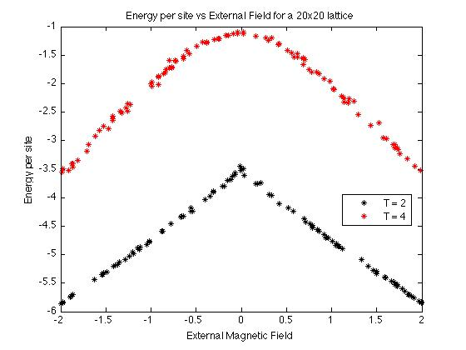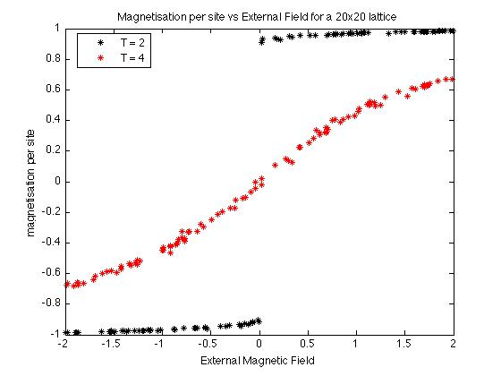

Figure 23 - J = 1

Figure 24 - J = 1

Figure 23 shows the energy against the strength of the magnetic field for two different temperatures. It shows how at a lower temperature the system is at a lower energy, which was seen in figure 6 for the ferromagnetic model. It also shows how the energy is the same regardless of the external fields direction. It can also be seen clearly that as the magnitude of the external field is increased, the energy per site of the system decreases. Figure 24 shows the magnetization per site against the external field. When the system is at a higher temperature, T > TC, the spins tend to align with the magnetic field. With a larger external field applied to the system at this temperature, more sites will align with the field. As the temperature increases though, the less effect the external field has on the system. With the system at lower temperatures, T < TC, the external field causes the spins to align in a particular direction, but only if the external field is large enough.

**4 Conclusion**

The use of a Monte Carlo method to simulate the Ising model, allowed the different thermodynamic quantities involved in the 2D Ising model to be obtained. The results that were found for the ferromagnetic model were consistent with the values and behavior of the system that we expected to find from the theoretical model. This meant the model could be used to simulate what happens for an antiferromagnetic model. It could also be used to see the effect of applying an external magnetic to the system, as there is no analytical solution for either of these scenarios.

The Metropolis algorithm required long simulation times to achieve a confident final state; this meant that a smaller lattice size had to be used in the model. Periodic boundaries were used to overcome this, but it still does not represent an infinite lattice exactly and why it does not fit the theoretical model exactly. Increasing the lattice size it not the only way of improve the results, the number of evolution steps that were taken for each system could have been increased to make sure that each system had reached a confident final state.

Further things that could have been looked into would have been seeing how the model works for various different dimensions and not just sticking to 2. The main part that could have been looked into for this particular simulation would have been how the correlation length varies with the temperature of the system. Another option would have been to choose what the initial set up was and see how the initial state of the system affected the final outcome. Another part to vary would be the structure of the lattice used within the model; the shape could be changed to better model the phase transition in real substances.

# References

Huang, K. (1963). *Statistical Mechanics.*

Metropolis, N., Rosenbluth, A. W., Rosenbluth, M. N., Teller, A. H., & Teller, E. (1953). Equation of state calculations by fast computing machines. *The Journal of Chemical Physics* , 21(6):1087-1092.

Onsager, L. (1944). *Phys.Rev.64.*

Yang, C. N. (1952). The spontaneous magnetization of a two-dimensional Ising model. *Physical Rev* *, 85*, 808-816.